**Kick Start Project Report**

* **Given the provided data, what are three conclusions we can draw about Kickstarter campaigns?**

**Conclusion 1:**

Based on below data, Theater is most successful kick start project and at the same time, theater is the kick start project which has been failed mostly as well. Music is the second highest successful with less failures. Technology has nearly equal chance of success and failure

**Conclusion 2**

Based on below data in US most successful sub-category is Plays, which aligns with overall observation from conclusion 1

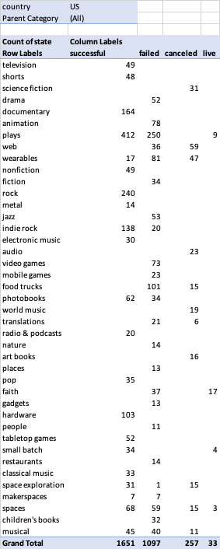

**Conclusion 3:**

Based on below data most failed sub-categories with no success are

1. Food trucks
2. Drama
3. Web
4. Animation
5. Video Games

* **What are some limitations of this dataset?**
  + Out of 300,000, we have analyzed only 4000 kick start projects, which may not give a proper sample of the dataset
  + From the analysis, the dataset analyzed has more than 3000 projects from US, which give a more US based analyzed not a global trend
  + This data set has last data as of 2017, in a fast-changing business scenario it is not providing current trends
  + Explanation of each of the column headings were missing which forces us to make some assumptions on what each column represents for some of the non-obvious ones
* **What are some other possible tables and/or graphs that we could create?**
  + We can create a table based on % average donation and see that which category and sub-category has received more donation and less donation
  + We can create a graph based on countries and state of the kick start projects and see which country support most of the kick start projects
  + We can look at the trends in projects success based on some of the parameters like Goal, money pledged
  + We can look at the project success based on staff pick (True and False)
  + We can look at the factors affecting project success based on the parameters using regression analysis